CHILD EXPLOITATION
AND TRAFFICKING
A Two-Part Workshop Series

Workshop Part-One:  BP Energy Center or Via Webinar  Dec 6, Anchorage, Alaska, 1-5 pm | WORKSHOP ONE AGENDA  CHILD EXPLOITATION: A Look at the Problem  $794 CE  - What is Child Exploitation  - The Role of Pornography  - Understanding Child Lures  - The Impact of Shame for Victims and Consumers
Workshop Part-Two:  BP Energy Center or Via Webinar  Dec 13, Anchorage, Alaska, 1:30-5:30 pm | WORKSHOP TWO AGENDA  CHILD EXPLOITATION: A Look at the Solution  $794 CE  - Increasing Awareness  - Restoring Relational Brokenness  - Demand Reduction  - Recovery for Victims

Continuing Education Units Available. $10 CE certificate fee.
Gene McConnell, Owner/Founder
Authentic Relationships International

For over three decades, Gene has served as a relational health coach, consultant, and/or Vice President of Victim Assistance for the National Coalition for the Protection of Children and Families. He has developed several programs that address the issue of shame and seeks to reverse the devastating trends of our sexualized culture. His work has been recognized and awarded for its outstanding leadership by the Los Angeles County Board of Supervisors, the Vice Division of the Los Angeles Police Department, and the Philippines National Police Force. He is also recognized as a subject matter expert on pornography, exploitation, human trafficking, and addiction.

Alisa L. Drake, MA, LPC
Owner, Turnagain Center

Alisa is a Licensed Professional Counselor and has been working as a clinician in Alaska for nearly two decades. She is a passionate advocate for those who have been harmed by sexual violence, abuse, and neglect. She is small group therapist and a certified Sex Offender Treatment Provider. Having worked in both men’s and women’s prisons, she is uniquely equipped to provide hope, healing, and recovery opportunities for both those who have been harmed and those who have caused harm. Her agency, Turnagain Center, provides quality continuing education opportunities to mental health professionals of Alaska.

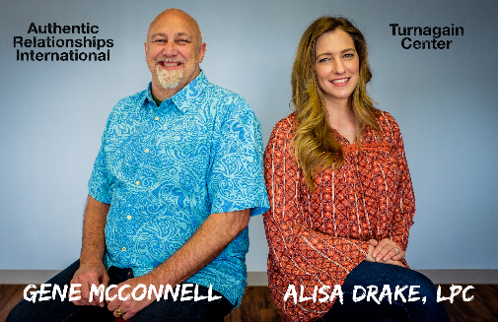

Register Online by Visiting:
www.turnagaincenter.com

